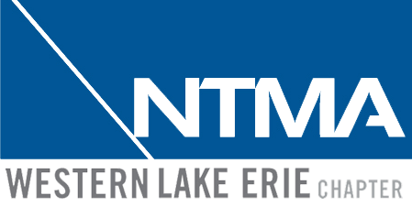

2023 Manufacturer’s Golf Outing
Supporting Skilled Trades in NW Ohio and SE Michigan

The Manufacturer’s Golf Outing, Supporting Skilled Trades in Northwest Ohio and Southeast Michigan will take place on Friday, September 15th, 2023, at Giant Oak Golf Club in Temperance Michigan. We anticipate a full course with proceeds going to local career tech programs.
Grab the top golfers on your management team and/or leaders in your shop and bring them out to the course. This is a great opportunity to get out with your team, relax, hit some balls, and have some fun. It Is also a great opportunity to network with other area manufacturers and leaders. It will be a 4-person scramble. The cost to golf this year will be $100 per player or $400 per team. The entry fee will include a hotdog, chips, and drink for lunch, a beer/beverage ticket and a steak dinner afterwards, as well as some prizes. If you do not have a team, but still want to play, we will do our best to find you a team. Mulligans will be included and there will be a 50/50 raffle.

Where: Giant Oak Golf Club
1024 Valetta Dr.
Temperance, MI 48182

When: Friday, September 15th
Shotgun Start at 10am

To make our event a success, we are asking the manufacturing community to support this outing through sponsorship and participation. Your involvement with this outing will assist in educating the future of the manufacturing community. Now, more than ever, our cause is important. As many of you can relate to, workforce development is a constant battle. Please email Ruth Curtis with your registration and sponsorship forms at ohiolanger@aol.com.

Manufacturer’s Golf Outing
September 15th, 2023
Shot Gun Start 10am
Giant Oak Golf Club
1024 Valetta Dr.
Temperance, MI 48182

Registration Form
Individual Player(s)………..$100.00 X ______ = $______
Team of Four ………………………………………..…… $ 400.00

Name(s) Company Name
1._______________________________________
2._______________________________________
3._______________________________________
4._______________________________________
*A portion of the proceeds to benefit local career tech programs*
Email registration to Ruth Curtis: ohiolanger@aol.com

***Please make checks payable to NTMA Western Lake Erie Chapter***
Mail payments to:
NTMA Western Lake Erie Chapter
P.O. Box 118018
Toledo OH 43611

*Sponsorship is needed by September 1st, 2023*

**Registration and payment must be received by September 6th, 2023
Contact Ruth Curtis ● 419-261-3615 ● ohiolanger@aol.com

