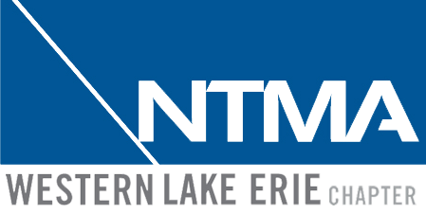
**Proceeds Benefit the NTMA Western Lake Erie Trade School**
Please have selected sponsorship submitted by September 1st, 2022
2022 NTMA Golf Outing |Sponsorship Levels
Western Lake Erie Chapter of NTMA
PO BOX 118018
Toledo, OH 43611
419-261-3615 | ohiolanger@aol.com

Platinum Sponsor(s): $1,000.00  - Name or logo in all tournament materials  - One foursomes included  - NTMA Website Banner Logo (1 year)  - Table for advertising materials - optional  - Opportunity to speak at the post outing reception  - Large format hole sponsor sign  Gold Sponsor(s) $750.00  - Name or logo in all tournament materials  - One twosome included  - Mulligan sponsor with company name  - NTMA Website Banner Logo (1 year)  - Special Recognition at the post-outing reception  - Hole sponsor sign located at tee box  Silver Sponsor: $500.00  - One twosome included  - Recognition at post-outing reception  - Hole sponsor sign located at tee box  Registration Form: | Lunch Sponsor: $500.00  - Name or logo at lunch on display  - Name or logo on lunch ticket  - Hole sponsor sign located at tee box  Hole Sponsor: $100.00  - Hole sponsor sign located at tee box
Company Name ________________________
Sponsorship Level ________________________
***Email form to Ruth Curtis: ohiolanger@aol.com

